

**HTML COURSE**

**ACHIVERS ACADEMY**

**Chapter – 1**

**HTML Overview**   
HTML stands for hypertext markup language   
  
**Language :-** Languages are used to communicate from one person to another person. Name of some   
**languages :-** English, Hindi, Tamil etc . Levels of computer languages Lo level or machine language Middle level or assembly language High level language

**Levels of computer languages-**

* Low level or machine language
* Middle level or assembly language
* High level language

**Low level or machine language-**

Low level language written in binary number that means 0 and 1 used to develop an operating system for particular machine. Ex-  


**Middle level or assembly language**-   
Middle level language written in english and it contains assembler to translate english code in binary that means machine language used to develop an operating system for particular machine. Ex-

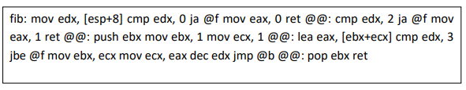

**High level language**-   
High level language written in english and it contains compiler and interpriter to translate english code in binary that means machine language used to develop an application softwares. Ex-

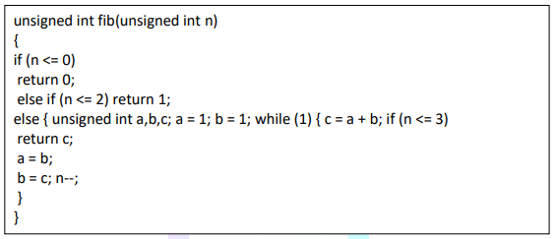

**About HTML** –

HTML stands for Hypertext Markup Language, and it is the most widely used language to write Web Pages.   
  
As its name suggests, HTML is a Markup Language which means you use HTML . to simply "mark-up" a text document with tags that tell a Web browser how to structure it to display.

**Chapter – 2  
 html tags**

**What is tag ?**

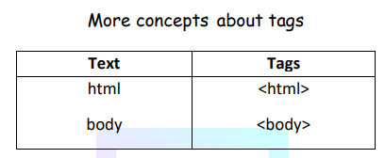A text surrounded by angle brackets is known as tags ex-

**Use of tags**-   
Tags are used to display our contents on webpage and it also defines the place of our contents .

**Important topics about tags.-**

1. A tag starts with <>bricked and closed with </> Ex. <html></html>.
2. A start tag also called opening tag and closed tag also called closing tag.
3. A tag must be closed with </> brickets
4. A tag marked our content to display them on webpage Ex. <html> our content</html>

**Chapter – 3  
 html versions & Elements**

HTML ( Hyper text markup language ) is Developed by Team Berners-Lee

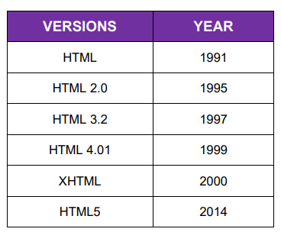

**HTML ELEMENTS**

An html element must have contents   
 Example : -

**<body> :**Starting tag   
 **contents :** My name is amit

**</body> :** Closing tag

**Chapter – 4**

**html Doctype declaration & typography**

**Doctype Declarations-**

Doctype declaration is a comment that tells in which version of HTML coding is done.

The doctype declaration tells our web server that we are coding in HTML

**Types of Doctype Declaration-**

1. HTML 4.01

2. XHTML

3.HTML 5

**1.) HTML 4.01 Doctype Declaration Syntax :-**

<!DOCTYPE HTML PUBLIC “//W3C//DTDHTML4.01Transitional//EN””http:w3.org/tr/html4/loose.dtd”>

**2.)XHTML& HTML 4.01 Doctype Declaration Syntax :-**

<!DOCTYPE HTML PUBLIC”-//W3C//DTD HTML 4.01//EN”http://www.w3.org/TR/html4/stict.dtd>

**3.)HTML 5 Doctype Declaration Syntax :-**

<!DOCTYPE html> And <!doctype html>

**NOTE :-**

* Always you have to do doctype declaration in html 5 version
* If you do the doctype declaration in html5 version then you can take advantage of all the features of HTML 4 and XHTML.

**HTML 4 basic Structure in HTML 5 Doctype Declaration.**

<!DOCTYPE html>  
<html>  
<head>  
<title>  
Write Title Content Here  
</title>  
</head>  
<body>  
Write Body Content Here  
</body>  
</html>

**Typography tags**

**Heading text tags**

**<h1>ACHIVERS ACADEMY</h1>**

**<h2>ACHIVERS ACADEMY</h2>**

**<h3>ACHIVERS ACADEMY</h3>**

**<h4>ACHIVERS ACADEMY</h4>**

**<h5>ACHIVERS ACADEMY</h5>**

**<h6>ACHIVERS ACADEMY</h6>**

**Paragraph text tags**<p>welcome to stp computer education</p>

**Centered text tags**

<center> Center Content write Here</center>

**Moving text tags**<marquee>Moving Content Write Here</marquee>

**Chapter – 5**

**Html Formatting tags**

**Empty Element Tags:-**<hr>= horizontal line Tagb  
<br>= break line

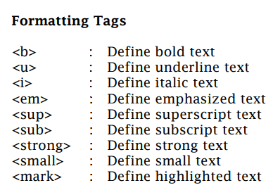**Pre Formatting tag:-**<pre>= This tag is accept keyboard formatting

**Chapter – 6**

**Html Attributes**

**HTML Attribute is the way to optimize the features of tag.**

**Attributes are always use in opening tag. Example :-**

**<tag attributename=”value”></tag>  
All HTML element have attributes**

|  |  |  |
| --- | --- | --- |
| **TAG NAME** | **ATTRIBUTES NAME** | **VALUE** |
| **Body** | Bgcolor | “blue” |
| background | “”image.img” |
| Text | “blue” |
| Link | “green” |
| **<h1>to<h6>** | Align | “left” “center” “right” |
| title | “any text” |
| **<hr>** | Color | “red” |
| Width | “”25%” “100” |
| Size | “10” |
| align | “left” “right” “center” |
| **<marquee>** | Direction | “up” “dwon” “left” “right” |
| Behaviour | “scroll” “alternet” |
| Scrollamount | “50%” “20” |
| bgcolor | “red” |

.